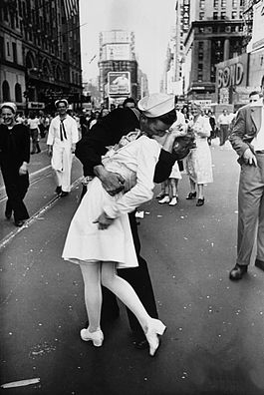

Want to know the Story behind this Iconic Photo?
Then join us to hear the History
Presented by Pat Loeswick of CIRCLE 2.1
October 18, 2023 at 10am
First Presbyterian Church
149 Broad Street
Tonawanda, NY

Refreshments will be served. All are Welcome

