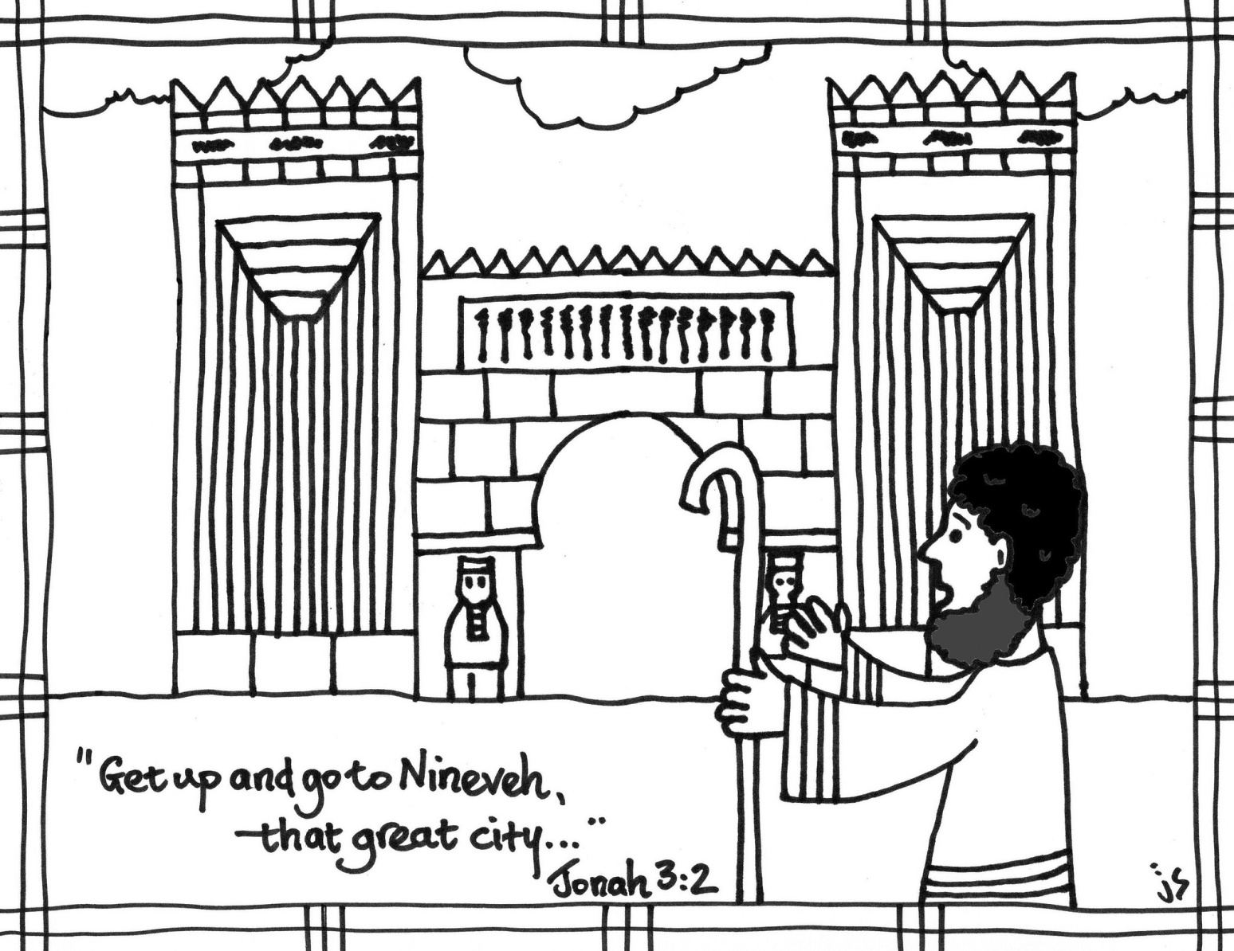

First Presbyterian Church
149 Broad Street
Tonawanda, New York 14150 ~ 2111
Church: (716) 692-1319
Rev. Dr. Rebecca Chaffee

Come, Worship the Lord, Our God
3rd Sunday after Epiphany
CCLI License # 2839486

January 21, 2024 10:30am

PRELUDE

WELCOME AND ANNOUNCEMENTS

CALL TO WORSHIP
The Word of the Lord came,
hope for all people cradled in his arms.
the Word of the Lord comes,
calling us out of our comfort zones, to go where grace is needed most.
The Word of the Lord will come,
gathering all the outsiders and insiders into one community of the kingdom.

GATHERING PRAYER
The present form of this world is passing away. Therefore, help us to keep our focus on you, Lord, for true power and steadfast love belong to you. Amen.

*HYMN:“Blest Be the God of Israel” #109 MERLE'S TUNE

CALL TO CONFESSION
Now is the appointed time. Pour out your hearts to God, bringing those harmful words you spoke, the chances to help you turned your backs on, and the foolish choices of your lives. Offer them to the One who longs to hear us, trusting that God will forgive us.
PRAYER OF CONFESSION
Our comfortable lives convince us we do not need to follow Jesus, Steadfast God. Our work provides for our wants, so we have no need for your grace. Our friends are found through social media, so we do not need your community. Our fear of the beliefs and cultures of others makes us sure that we do not need to share your grace with them.
Forgive us for dragging our feet as Jesus' disciples, Compassionate God. May we get up from our comfort zones and step out in faith. May we go to all the uncomfortable places to bring hope. May we proclaim with our lips, but especially with our lives, that the kingdom of love is near, brought by Jesus Christ, our Lord and Savior.
Silence is kept

ASSURANCE OF PARDON
Now, after we confess, we hear the good news proclaimed: God hears our words, God sees our changed hearts, God's steadfast love is poured out upon us!
We will trust in God, in whom our salvation rests. Thanks be to God, we are forgiven! Amen.
PASSING OF THE PEACE

PRAYER FOR ILLUMINATION
Speak to us your word, O God, that we may hear Jesus’ call to be his disciples. Amen.

SCRIPTURE LESSONS
First Reading: Jonah 3:1-5, 10
¹The word of the LORD came to Jonah a second time, saying, ²"Get up, go to Nineveh, that great city, and proclaim to it the message that I tell you."
³So Jonah set out and went to Nineveh, according to the word of the LORD. Now Nineveh was an exceedingly large city, a three days' walk across. ⁴Jonah began to go into the city, going a day's walk. And he cried out, "Forty days more, and Nineveh shall be overthrown!" ⁵And the people of Nineveh believed God; they proclaimed a fast, and everyone, great and small, put on sackcloth.
¹⁰ When God saw what they did, how they turned from their evil ways, God changed his mind about the calamity that he had said he would bring upon them; and he did not do it.
This is the word of the Lord. Thanks be to God.

ALL GOD’S CHILDREN

PSALM 62:5-12
⁵For God alone my soul waits in silence,
for my hope is from him.
⁶He alone is my rock and my salvation, my fortress;
I shall not be shaken.
⁷On God rests my deliverance and my honor;
my mighty rock, my refuge is in God.
⁸Trust in him at all times, O people; pour out your heart before him;
God is a refuge for us. Selah
⁹Those of low estate are but a breath, those of high estate are a delusion;
in the balances they go up; they are together lighter than a breath.
¹⁰Put no confidence in extortion, and set no vain hopes on robbery;
if riches increase, do not set your heart on them.
¹¹Once God has spoken; twice have I heard this:
that power belongs to God,
¹²and steadfast love belongs to you, O Lord.
For you repay to all according to their work.

ANTHEM: “In My Life” - Choir Bob Kilpatrick
Congregation is invited to join in on verse 4 - #468
In our world, Lord, be glorified, be glorified. In our world, Lord, be glorified today.

Gospel Reading: Mark 1:14-20
¹⁴Now after John was arrested, Jesus came to Galilee, proclaiming the good news of God, ¹⁵and saying, "The time is fulfilled, and the kingdom of God has come near; repent, and believe in the good news."
¹⁶As Jesus passed along the Sea of Galilee, he saw Simon and his brother Andrew casting a net into the sea--for they were fishermen. ¹⁷And Jesus said to them, "Follow me and I will make you fish for people." ¹⁸And immediately they left their nets and followed him.
¹⁹As he went a little farther, he saw James son of Zebedee and his brother John, who were in their boat mending the nets. ²⁰Immediately he called them; and they left their father Zebedee in the boat with the hired men, and followed him.
This is the word of the Lord. Thanks be to God.

SERMON: “Follow the Light!” Rev. Dr. Rebecca Chaffee

SERMON HYMN: “Lord, You Have Come to the Lakeshore” #721 PESCADOR DE HOMBRES

PASTORAL PRAYER AND PRAYERS OF THE PEOPLE

THE LORD’S PRAYER
Our Father who art in heaven, hallowed be Thy name. Thy kingdom come, Thy will be done, on earth as it is in heaven. Give us this day our daily bread; and forgive us our debts, as we forgive our debtors; and lead us not into temptation but deliver us from evil. For Thine is the kingdom and the power and the glory, forever. Amen.
MOMENT FOR MISSION: Nancy Rolando
CALL TO THE OFFERING
God is our rock and our fortress. Let us celebrate our salvation by fearlessly giving a portion of what has already been given to us.

THE OFFERTORY

DOXOLOGY: “Praise God, from Whom All Blessings Flow” #607 OLD HUNDREDTH

PRAYER OF DEDICATION
May these gifts we offer show we recognize your claim upon us, Holy God. Use them so your grace, your love, and your hope may be shared with everyone who needs them. Amen.
*CLOSING HYMN:“Will You Come and Follow Me” #726 KELVINGROVE

CHARGE
Now, take the word of God into the world.
we will place hope in the arms of others.
Now, take the word of Jesus into the world.
We will follow to serve beside him in all the broken places.
Now, take the word of the Spirit into the world.
We will bring others near to the kingdom where all are welcome.

SUNG BENEDICTION: “May the God of Hope Go With Us” #765 ARGENTINA

BENEDICTION

From the Finance Team: Financial statements for 2023 contributions will be available in the rear of the Sanctuary this Sunday January 21st. You may also stop by the church office the following Tuesday, Wednesday or Thursday during normal business hours as well as the following Sunday, January 28th to pick up your statement. It would be helpful to the church if you have the means to pick up your statements, so we do not have to mail them out.

Volunteers This Week : Volunteers Next Week 1/28 :
Liturgist:Bonnie Zimmer Liturgist: Sue Schurr
Tech: Betsy Crocker Tech: Betsy Crocker
Usher: Alvin Marohn, Nathan Harrington Usher: Billy Welch, Jessica Schurr
Coffee Hour: Laura Marohn, Adam Harrington Coffee Hour:
Greeter(s): Alvin & Laura Marohn, Greeter(s):
Nathan & Adam Harrington
PRAYER CONCERNS
The prayer concerns have recently been updated. If you have a prayer request, please
contactPastor Rebecca at 315-317-6140 or the church office at 716-692-1319.

CALENDAR
Sunday, Jan 21
9:30am Faith Formation (All Ages)
10:30 am Worship for all ages (Sanctuary)
11:30am Coffee Fellowship for all ages (Parlor)

Monday, Jan 22
10:00 am Alcoholics Anonymous (Circle II Basement)
6:00pm Christian Ed Committee
7:00 pm Session Meeting

Tuesday, Jan 23
9:00am – 2:00pm Office Hours
11:00am Pastor’s Study (Book Club)
12:00pm Worship Team
1:00pm Deacons Meeting
7:00pm Pastor’s Study (Book Club)

Wednesday, Jan 24
9:00am – 2:00pm Office Hours

Thursday, Jan 25
9:00am – 2:00pm Office Hours
10:00am Alcoholics Anonymous (Circle II Basement)
6:00pm Hearts4Worship
6:45pm Bell Choir
7:15pm Choir

Saturday, Jan 27
10:00am Alcoholics Anonymous (Circle II Basement)

Sunday, Jan 28
9:30am Faith Formation (All Ages)
10:30 am Worship for all ages (Sanctuary)
11:30am Coffee Fellowship for all ages (Parlor)

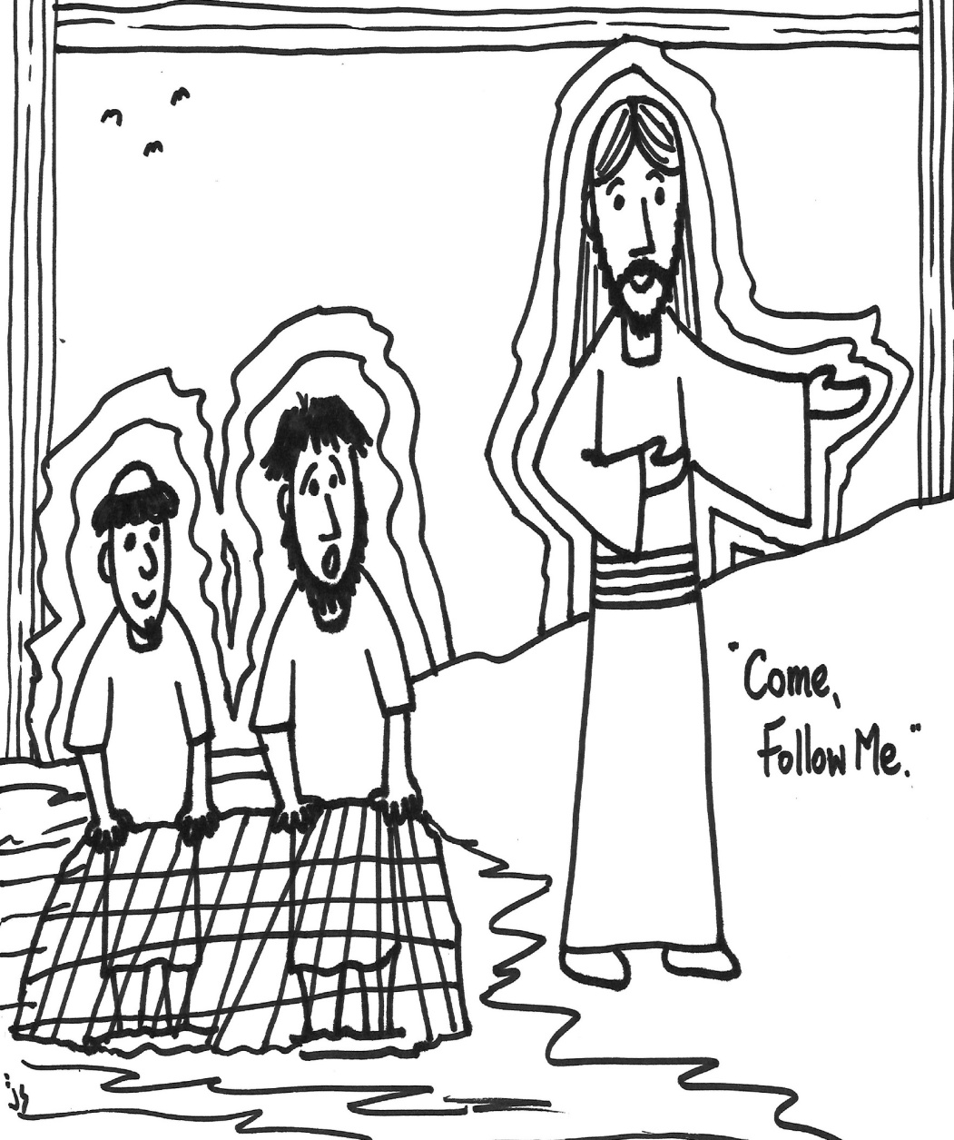

Portions of the liturgy (c) Thom M. Shuman and Feasting on the Word. Images by Rev. John Stuart, stushieart.com

